Tuples:-

A tuple refers to a collection of objects in python which are ordered and can’t be changed. The python objects here may be strings, lists, tuples, integers etc.

1. Insertion order is preserved: The order in which elements are added to the tuple is the order in which the output will be displayed.
2. Immutable: Once if we create a tuple object, then we cannot modify the content of the tuple object. This is the only feature which differentiates tuples from the lists.
3. Tuple can store duplicates.
4. Tuple can store the same type of objects and different types of objects as well.
5. Index plays the main role in tuple.
6. Tuple supports both positive and negative indexes. Positive index means forward direction (from left to right). Negative index means backward direction (from right to left).
7. We can create a tuple by using parenthesis () symbol. Parenthesis is optional but it’s recommended to use.
8. Inside the tuple every object should be separated by comma as a separator.

**There is a question in our mind that when we have list in python then why we should tuples ?**

In real-world applications, tuples are extremely useful for representing records or structures as we call in other programming languages. These structures store related information about a subject together. The information belongs to different data types. For example, a tuple that stores information about a student can have elements like roll_no, name, course, total_marks, avg. etc. If you carefully observe, these individual elements can have different data types. For example, roll no can be an integer or an alphanumeric value, name and course will of course be string, and total_marks and avg can be floating point numbers.

**Creating Tuples:-**

To create a tuple we will use () operators.

Tup1=() #

Tup1=(“python”, “is”, “a”, “programming”, “language”)

Print(Tup1)

o/p:- (“python”, “is”, “a”, “programming”, “language”)

***Note:-***  In case your generating a tuple with a single element, make sure to add a comma after the element.

*****Note:- parenthesis is optional for tuple***

**Slicing tuple in python :-**

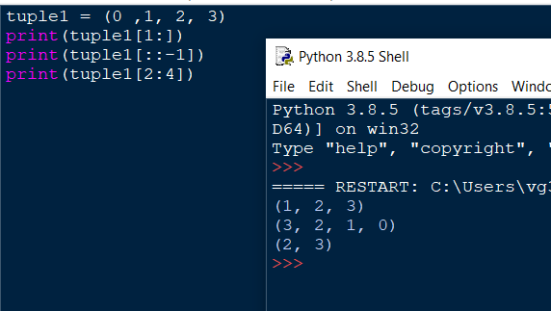

Slicing is same as in list we studied.

**Concatenation of tuple in python:-**

To concatenate the python tuple we will use plus operator(+)

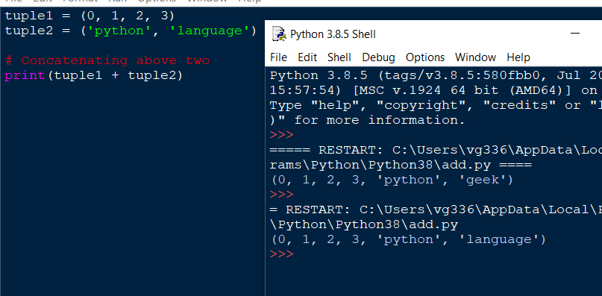

**Accessing value in tuple in python:-**

**Method 1:- using positive index:-**

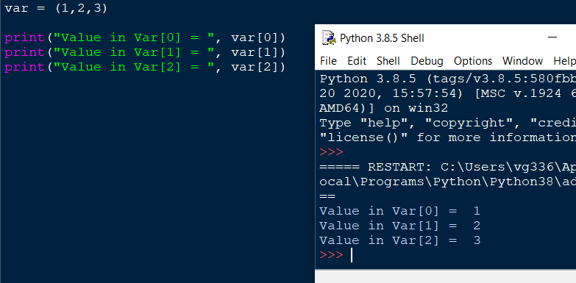

**Method 2:- using negative index**

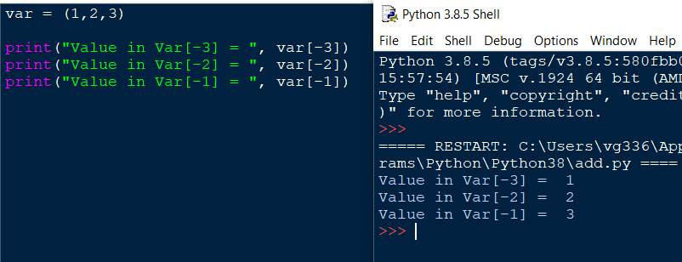

**Deleting a Tuple:-**

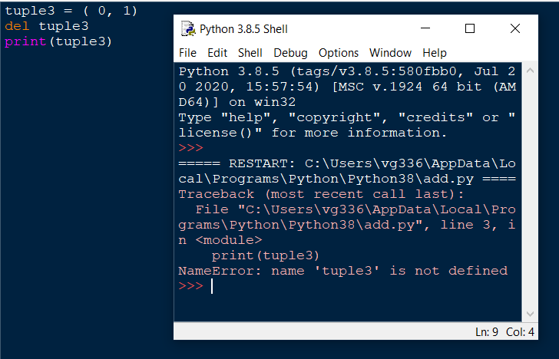

**Built in tuple function :-**

We can create a tuple by using tuple() function.

We can also convert list in to tuple by using tuple() function.

